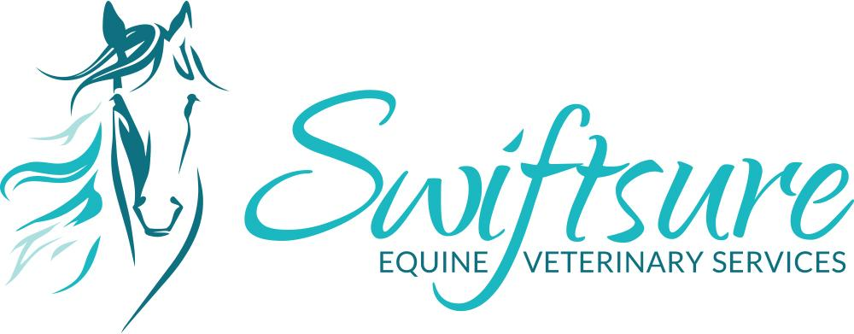

Intra-Articular Injections

Intra Articular Injections
Intra-articular (joint) injections will be performed by Dr. Danica Olenick, Dr. Kaitlin McDonald or Dr. Reina Fennell on your horse. Despite the provision of professional, quality care, this procedure does carry certain inherent risks. While every reasonable effort will be made to prevent and/or mitigate these risks, you should be aware that complications can and do occur. This procedure will be performed under standing sedation with possible need for a nose twitch. Standard procedures to maintain sterility throughout the treatment will be employed. Although the risk of injury or death with sedation and IA injections are considered to be minimal, some animals may develop disease conditions or complications that will require additional treatment or surgery, raising the cost of this procedure above the routine expenditure. Risks are greatest in large, old, or medically compromised animals but can and do occur in any animal. Seldom, the severity of these complications may result in patient death or extreme morbidity, necessitating humane euthanasia. These complications include severe infection, anaphylaxis, allergic reactions, diarrhea, laminitis, or other musculoskeletal problems.
As the owner (or authorized agent of the owner) of the animal described above, I hereby give my consent to perform the following procedures:
1. ________________________________
2. ________________________________
I have carefully read, and fully understand, this consent. The fees associated with these services have been explained to me, and I agree to pay such fees at the time of service.

Owner’s signature and permission to commence treatment:

Date: __________________________

